Wheel tutorial

Create a cylinder and scale it down 0.25 in z axis

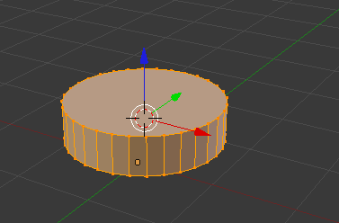

Now create two loops on the side of the cylinder and space them an even distance apart. Then select the middles faces all the eay around the cylinder and scale it inwards by 0.9

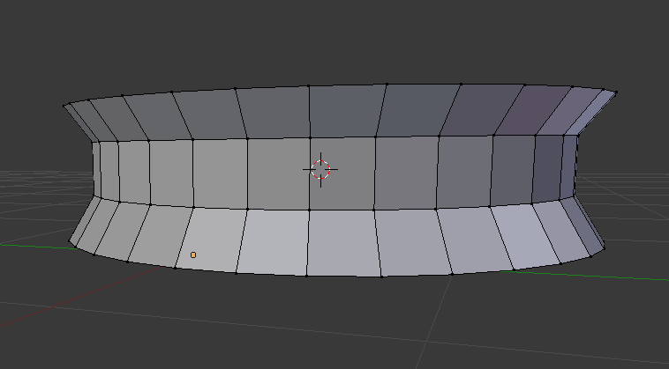

Now extrude the top and bottom then translate with g by 0.05 units. Do for both sides

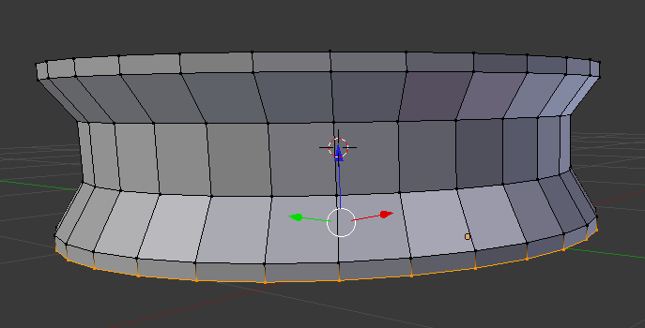

Next delete the side faces and select all vertices on the rim

Then extrude and scale inwards by 0.8 units

Then translate downwards by 0.05

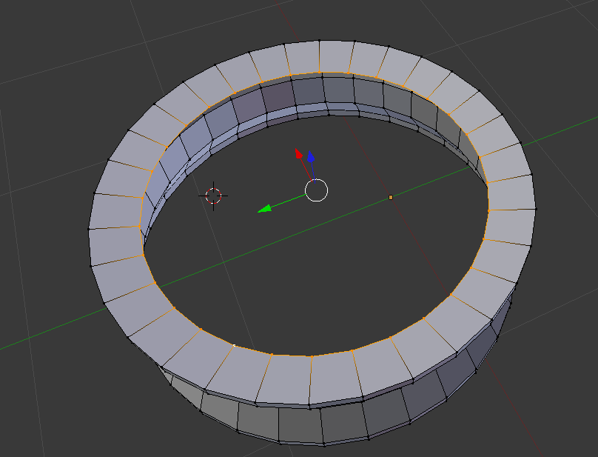 do for the other side.

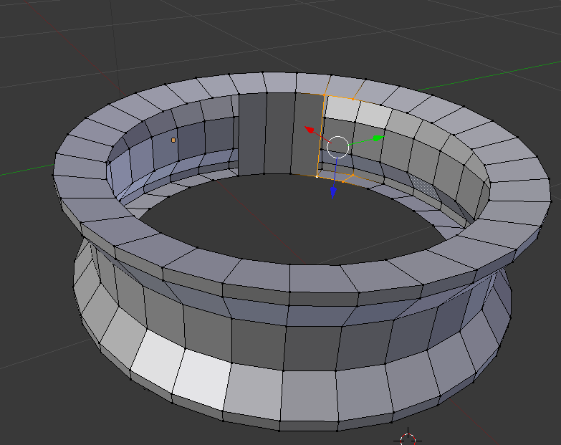

Now create faces for the inside of the wheel by selecting 4 points then clicking f

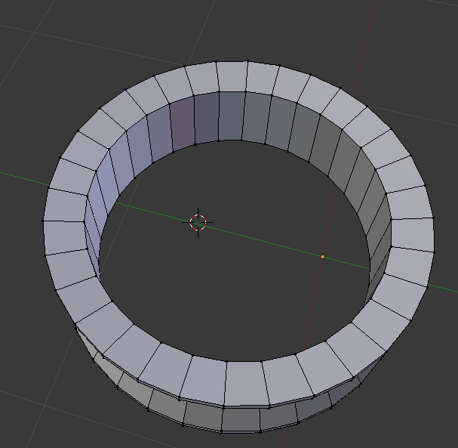

Now select the whoel object and shift s to bring cursor to selected. Then create a new cyclinder and scale it down by 0.2 then scale it in the z axis by 0.6

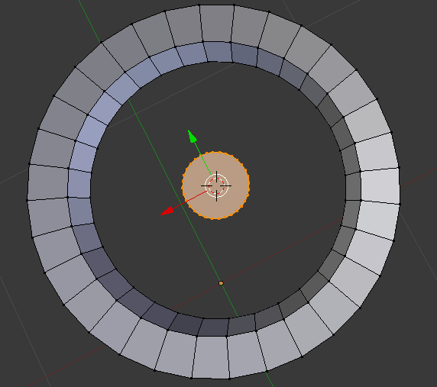

Now create another cylinder and rotate it in the y axis by 90 degrees

Then scale down by 0.2 in x and y

Then scale down the whole thing by 0.5

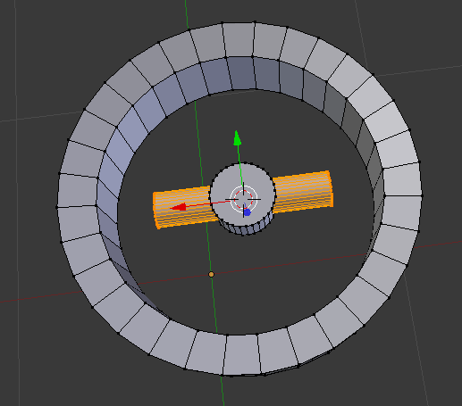

Scale it once more in the x axis by 0.8 and translate it in the x axis so it connects the inner cyclinder to the outer one. This pole will act as a spoke.

Duplicate the cylinder and place it in the opposite direction

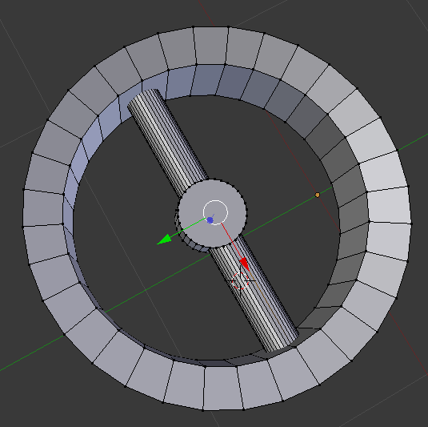

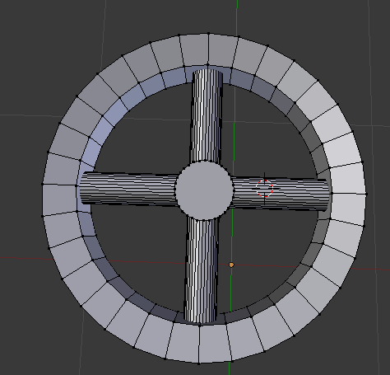 do the same for the rest of the spokes

Now move cursor to selected and add a torus shape

Switch to side view and ensure it is properly aligned

Next scale the torus shape so it fits correctly. I scaled mine to 1.1

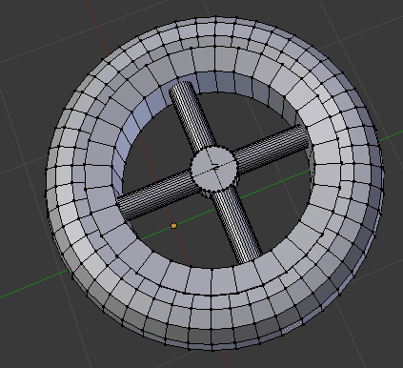

Now create two loops on the outer side of the wheel an equal distance form the middle line

Use alt click to select the whoel circumference. Then select the faces and extrude and scale inwards by about 0.98. this is to create the wheel threads.

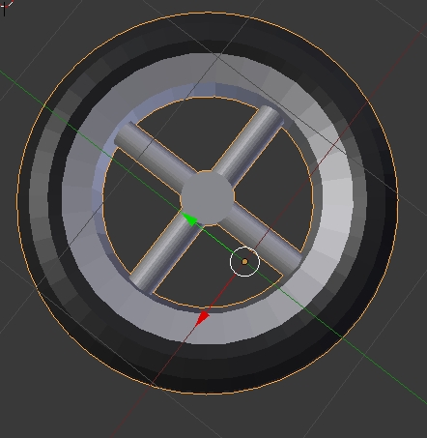 now add colour to the objects. Add a dark grey colour for the wheel and a silver colour for the spokes.